Andy Nguyen

Prof. William

Date: 4/1/2021

Homework: Module 2 - How to Design a Database: Crash Course

**I) Initialize :**

- Consider the entities **Team**, **Player**, **Coach** and **Parent** and their attributes.

The Entity Relationship Diagram (ERD) for given entities is as follows:

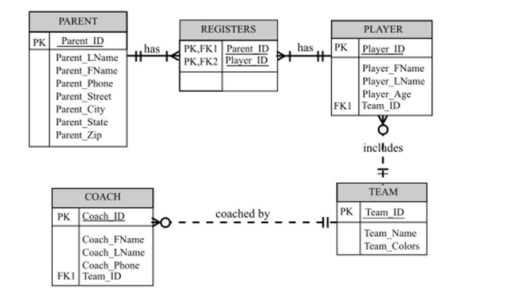

Explanation:

* The above Crow’s Foot Notation ERD notation contains boxes denotes the entities and line denotes the relationships.
* The cardinality of the relationship represents the uniqueness of the data for the column in a table.
* In the diagram, the “Team_Colors” attribute can be left with one attribute as user is not troubled with the more than one color separately.
* The next case, if there are some options that users may become interested in assigning the changed colors for a given team, then it should be modified the above diagram to fulfill this need . Therefore, the modify design by adding additional attributes “Team_Color1” and “Team_Color2” to the TEAM entity.
* The Entity Relationship Diagram (ERD) for two Team_Color attributes (“Team_Color1” and “Team_Color2” :

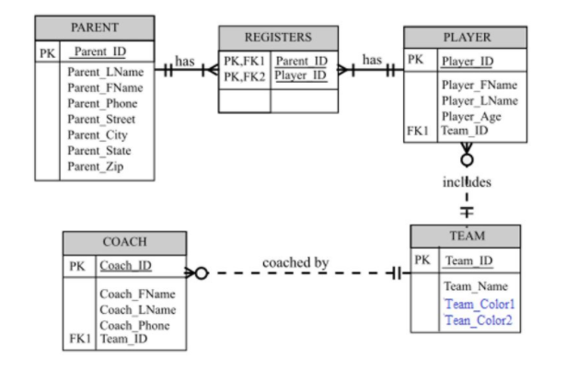

* The above model is a kind of limited solution because it will work only if teams have exactly two team colors but problem arises if some teams have more than two colors.
* If teams have more than two colors, then it will have to modify the data model with a separate table named “COLOR” to use the multi-valued colors OF “team” attribute.
* 🡪 The entity relationship diagram (ERD) for separate table COLOR:
* 